**Manuals for ‘Manage Specialty’**

**Brief of the ‘Manage Specialty’ –** This is the page where we manage specialty.

**1. How to manage specialty-.**

Steps:

1. Login to the site and go to ‘Specialty’ tab and click on ‘Manage Specialty’.
2. On ‘Manage Specialty’ page the listing of Specialty, ‘Add Specialty’ button and ‘Search Specialty’ button will display.
3. On this page we can edit and delete the existing records.
4. Click on ‘Add Specialty’ button for add new records.
5. The added new Specialty will display with respective specialty page.

1.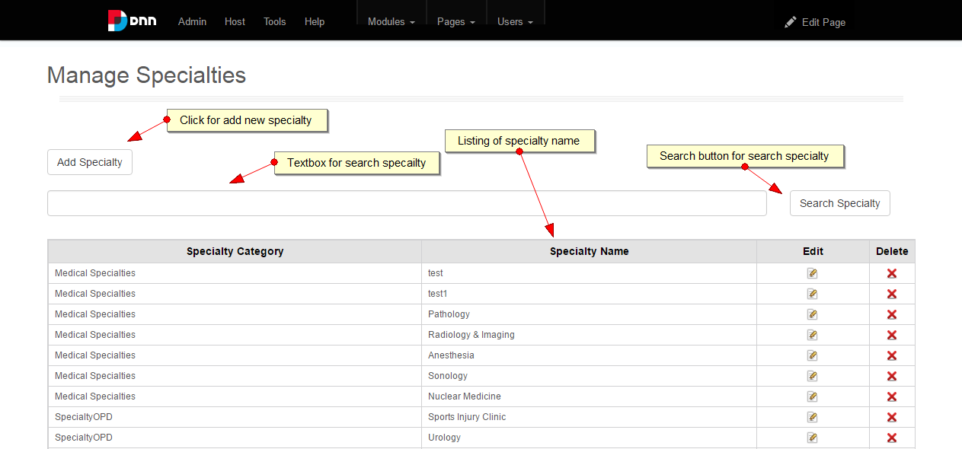

2.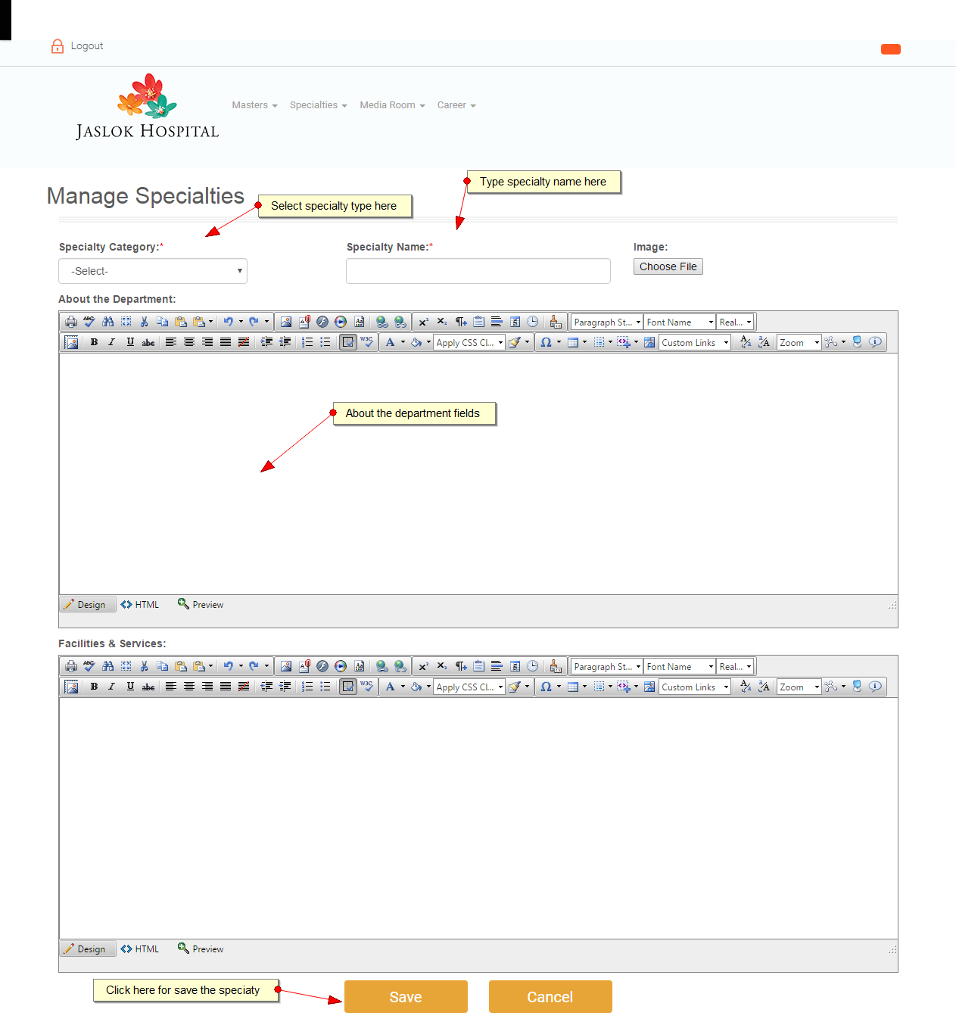

3.

